Bill2Pay 1099K

Deployment Guide

Date: 3/3/2017

**Statement of Confidentiality**

*The information contained herein shall not be disclosed, duplicated, or used in whole or in part for any purpose other than to evaluate the proposal, provided that if a contract is awarded to this offer as a result of, or in connection with, the submission of these information, the recipient shall have the right to duplicate, use or disclose the information to the extent provided in the agreement. This restriction does not limit the right to use information contained in the data if it is obtained from another source without restriction.*

**© 2016 RS Software (India) Ltd.**

Table of Contents

Abbreviations 4

Revision History 4

Approvals 4

Introduction 5

Deployment Guide 6

Database Creation 7

Database Schema execution and Master Data Creation 8

Application Deployment in IIS 9

Testing Deployment 13

# Abbreviations

|  |  |
| --- | --- |
| RS | RS Software |
| BRD | Business Requirement Document |
| TIN | Taxpayer Identification Number |
| MCC | Merchant Category Code |
| VPN | Virtual Private Network |

# Revision History

|  |  |  |
| --- | --- | --- |
| Date | Version Number | Change Description |
| 03/03/2017 | 1.0 Draft | First Draft |

# Approvals

|  |  |  |  |
| --- | --- | --- | --- |
| Role | Name | Title | Date |
|  |  |  |  |

# Introduction

This document captures the deployment details for the 1099-K development project undertaken by RS Software for Bill2Pay.

# Deployment Guide

Extract Provided ZIP file in to [USER DEFINED] location, the file structure looks as follows:   
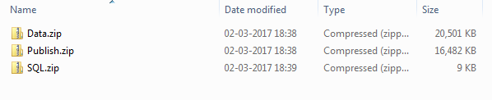Deployment package contains following section

* 1. Database Creation,
  2. Database Schema execution and Master Data Creation,
  3. Application Deployment in IIS
  4. Testing Deployment

# Database Creation

1. Open SQL Query analyzer and authenticate to Server
2. Create a new database from the navigation menu.  
   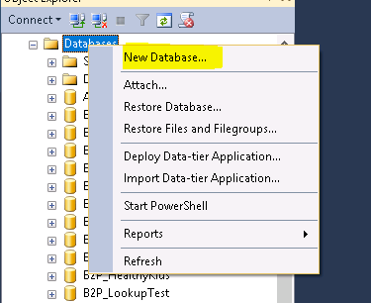

# Database Schema execution and Master Data Creation

1. Extracting SQL.zip into desired location, this will contain the script file “Bill2Pay_K1099_DB.sql”
2. Execute the script “Bill2Pay_K1099_DB.sql” in SQL Query Analyzer
3. This will perform the following task.
   1. Create Table/View/Procedure for the application
   2. Insert master data into following table
      1. User
      2. Role
      3. Merchants
      4. Payer
      5. Transmitter

# Application Deployment in IIS

Prerequisite:

1. IIS Management Console
2. DOT NET Framework 4.5
3. Network Connectivity with DB Server and IIS Server
4. Extract “Publish.zip” file in to user defined location, this will looks as follows  
   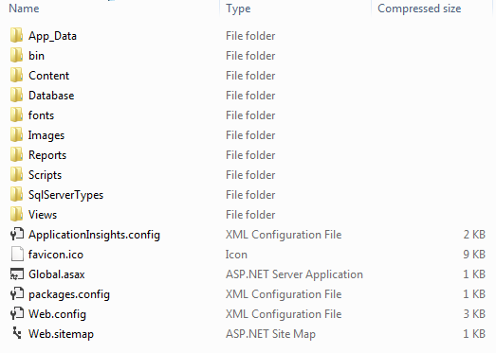
5. Open IIS Management Console in Windows explorer by running the command “inetmgr” command.

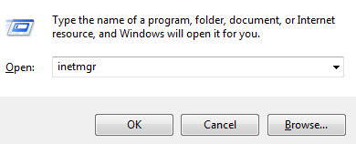

Note: User require extra privileges to open IIS Console

1. verify Dotnet Framework 4.0 is configured Application Pool

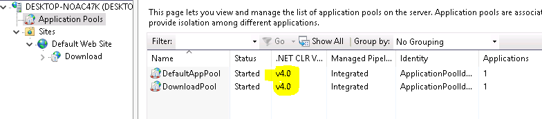

1. Create IIS Application using the navigation menu

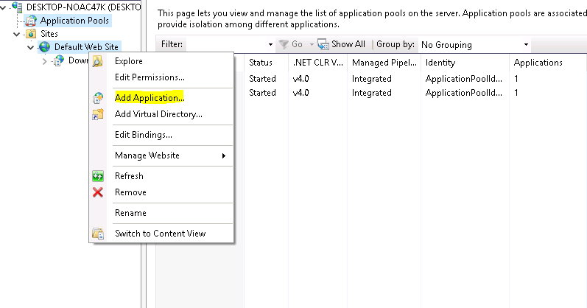

Right Click over Default Web Site, and “Add Application”

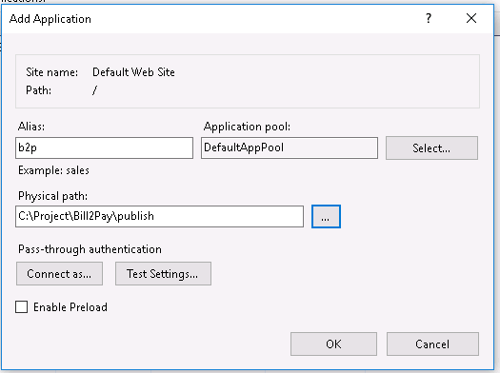

Provide necessary information.

1. Alias: [USER DEFINED NAME]
2. Application Pool: 4.0 Integrated
3. Physical File Path: Physical folder location of the application.
4. Verify Database Connection Settings

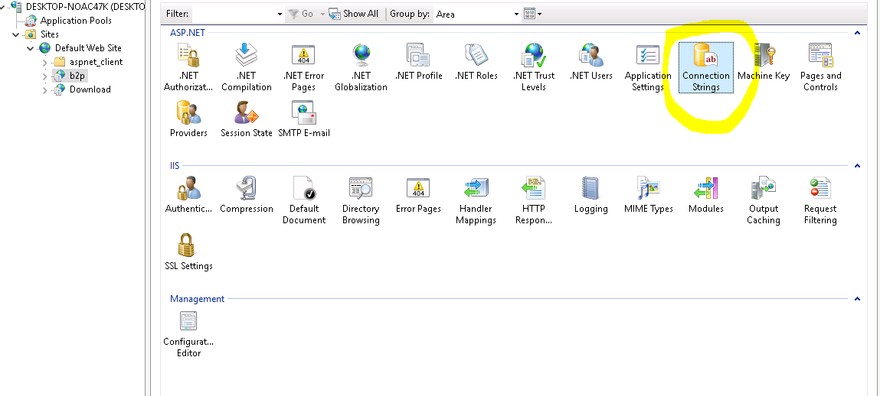

1. Change Database Connection accordingly

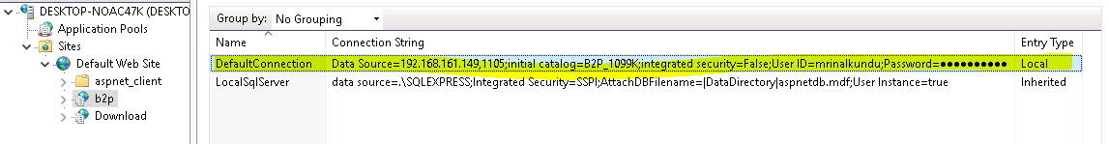

1. Enable Forms Authentication

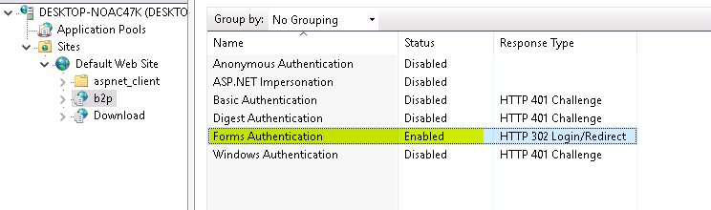

# Testing Deployment

1. Open the URL in browser will prompt for Login to the System.  
   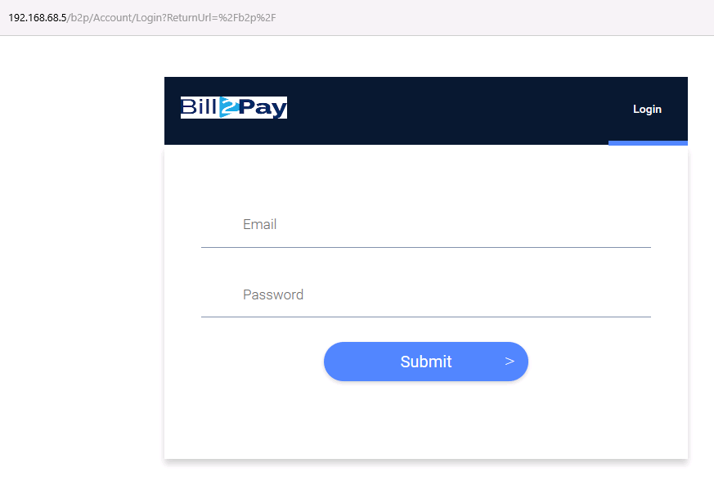
2. Initially two default role is mapped with the application
   1. Admin
   2. User
3. Initially two User is allowed to login to the System with corresponding Role
   1. [admin@b2p.com](mailto:admin@b2p.com) , PWD: Admin@123
   2. [user@b2p.com](mailto:user@b2p.com), PWS: User@123
4. User will be prompt to change password, when login to the system for the first time.  
   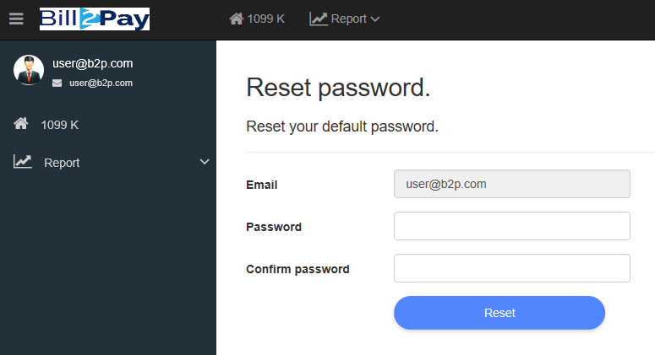
5. Import Transaction from the application Navigation menu.
6. Extracting “Data.zip” will looks as follows:  
   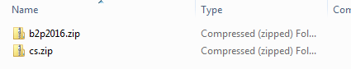  
   Note: Only the role “Admin” is allowed to perform the operation  
   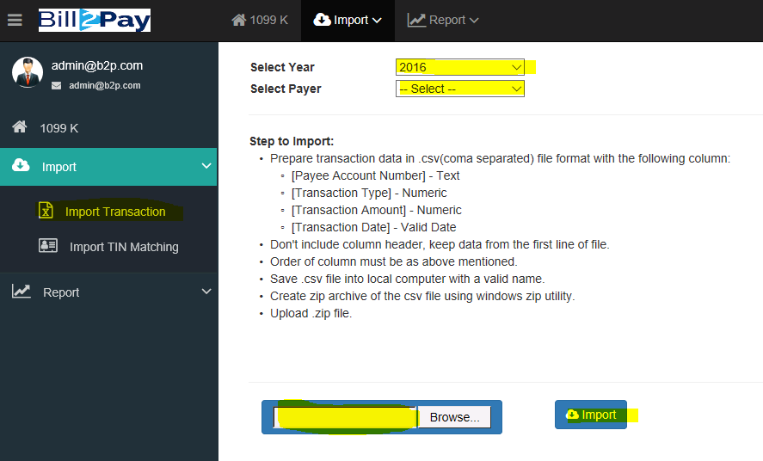
7. After successful Import of transaction List of merchant will show in “1099 K” listing.  
   